1. update pelanggan set nama_pelanggan='anggi' where id_pelanggan='1';

* 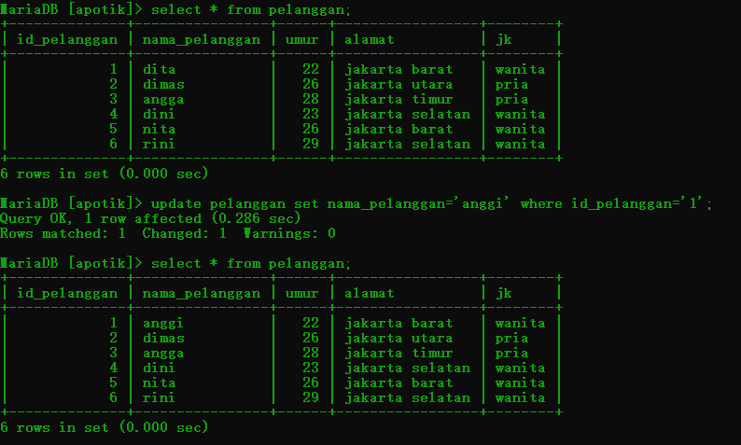

1. update pelanggan set umur='24',nama_pelanggan='rita' where id_pelanggan='6';

* 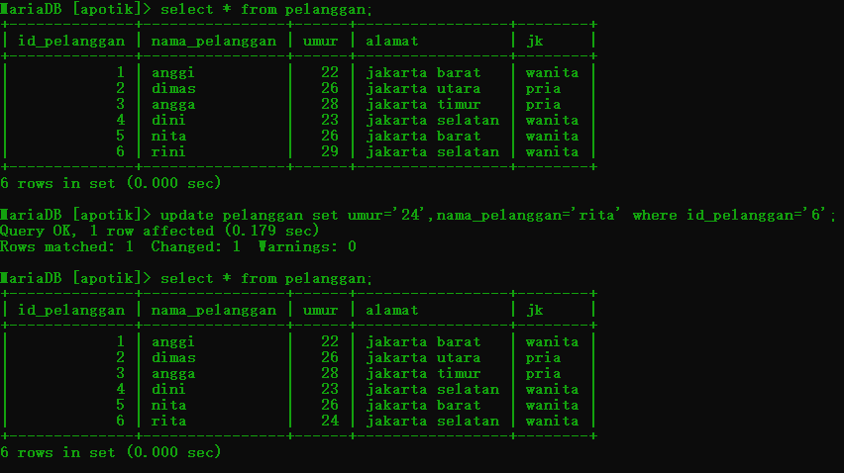

1. update pelanggan set nama_pelanggan='rani', umur='28' where id_pelanggan ='5';

* 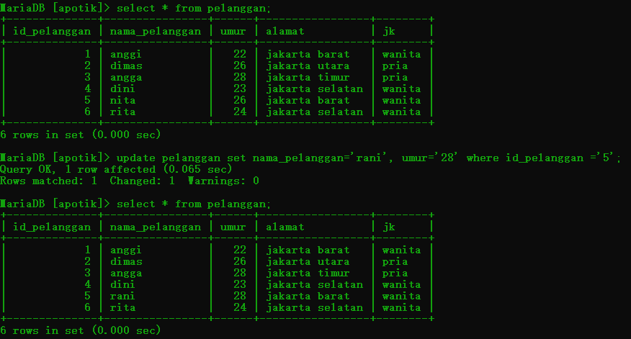

1. delete from pelanggan where id_pelanggan='5';

* 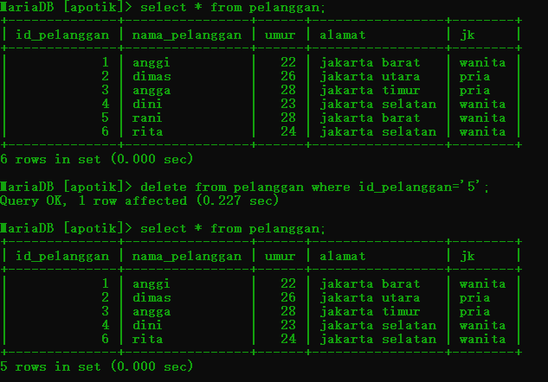

1. delete from pelanggan;

* 